PRESS RELEASE
2015 Financial Year: Gothaer Strengthens Equity Basis and Gains Market Share in Property Insurance

- Consolidated profit for the year on the up
- Equity basis again strengthened
- Rating agencies confirm good results
- Roll-out of CRM system on track

Cologne, 1 June 2016 – The Gothaer Group presents sound 2015 figures in a difficult market environment: its consolidated net profit for the year was up 14.5% to €134 million. Some of the profit was used to strengthen its equity basis. Group equity grew 3.3% and stood at €1,837 million at the end of 2015. The investment result rose 9.8% to €1,213 million. Gross premiums written, at €4.52 billion, remained at the previous year's level (+0.1%) in 2015.

The Property/Casualty segment grew above the market average. Thanks to a renewed rise in persons with supplementary insurance, Gothaer Krankenversicherung is seeing further growth in its supplementary health insurance business, while the Life Insurance segment posted a decline owing to the difficult market environment and the deliberately selective underwriting of single-premium policies.

Group premiums written, by segment
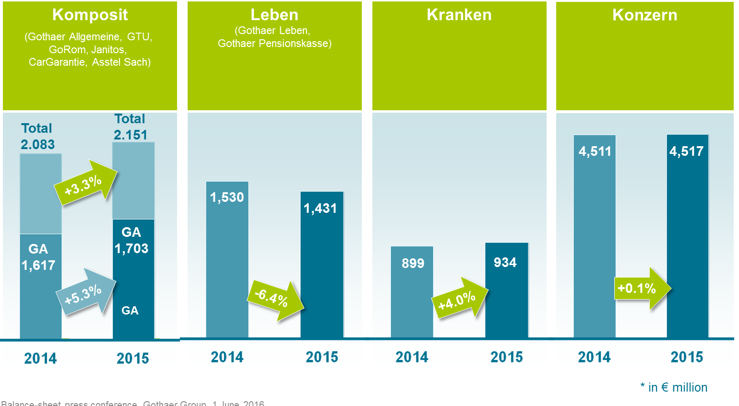

Gothaer Allgemeine: Property/casualty insurer gains market share
Gross premiums written by Gothaer Allgemeine Versicherung AG, at €1,703 million, were up 5.3% on the 2014 level, meaning that Gothaer's property/casualty insurer again grew above the market (+2.7%) and once more obtained high growth rates among private clients and corporate customers. "We set great store by providing comprehensive advice to our private clients and commercial customers. In 2015, we successfully focused on our commercial business and expanded our target-group orientation thanks to tailored-to-suit solutions. We'll go on working on this", reports Thomas Leicht, Gothaer Allgemeine CEO.

Renewable energies business field still on expansion course
Gothaer Allgemeine has been the leading insurer of windfarms in Germany and other EU countries for some years now and was able to expand this market position further in 2015: in the 2015 financial year, it was possible to increase sales revenue by 8.6% in the wind energy business field and 4.7% in the photovoltaics business field. Worldwide, Gothaer has insured some 16,500 windfarms, including nearly 15,000 systems in Europe.

Gothaer Leben: Consolidation of business model and realignment initiated
Gross premiums written by Gothaer Lebensversicherung AG in 2015 fell 6.8% to €1,294 million owing to a very difficult market environment and a deliberate decision to selectively underwrite single-premium policies. At a very early stage, the Company had focused its product development on the promising, strategic business fields 'company pension schemes', 'unit-linked pension plans' and 'biometric solutions'. "We'll be pursuing this path systematically and are working flat out on adapting our business model accordingly", says Michael Kurtenbach, CEO of Gothaer Lebensversicherung AG and Gothaer Krankenversicherung AG. "Here, the Biometrics and Pension-Plan units are and remain our core business fields. At the start of 2016, we launched our new, multi-channel-capable term life insurance products. Our new future-provision products with changed guarantees are to be launched shortly", continues Kurtenbach, discussing the 2016 product innovations.

Gothaer Kranken: Strong growth in supplementary insurance
Gross premiums written by Gothaer Krankenversicherung AG climbed 3.6% to €913 million. The number of persons with supplementary insurance grew further and stood at some 434,000 insured clients at the end of the year – equivalent to a 2.6% rise and growth above the market. "In 2016, our digitization offensive is going into the second round", says Kurtenbach. "We will be expanding our RechnungsApp (invoice app) – very popular with our clients – to include an Android version, and have launched an e-signature solution in the area of supplementary insurance. In addition, we have entered into cooperation schemes with start-ups to be able to help our customers with serious illnesses, like tinnitus and diabetes, even more comprehensively, better and faster using eHealth Services", says Kurtenbach, summing up the focuses for the year 2016.

Rating agencies confirm good results
On 15 April 2016, the international rating agency Fitch Ratings again confirmed the rating results for Gothaer Allgemeine Versicherung AG and Gothaer Lebensversicherung AG. The companies are still 'A'-rated and the ratings' outlook is stable. "The renewed confirmation of our rating results by Fitch Ratings shows the sound position of the Gothaer Group. It is precisely the Group's broad-based positioning with a strong property/casualty insurer that is an enormous added value in the current environment of low interest rates", says Dr. Karsten Eichmann, Gothaer Group CEO.

 | S&P (04.12.2015) | Fitch (15.04.2016)
Gothaer Allgemeine | A- | A
Gothaer Leben | A- | A
Gothaer Kranken | A-

Investment: Expansion of the asset classes real property and renewable energies
The Gothaer Group delivers very stable investment results despite a capital-market environment still characterized by low interest rates: the Group's net yield according to IFRS stood at 4.3% for the financial year 2015. "Our main changes in 2015 investment were the increase in the share quota at Gothaer Allgemeine to 5.8% and an expansion of the portfolio in the asset classes real property and renewable energies", sums up Harald Epple, Gothaer CFO. "The Gothaer Group has a strong lead on the German insurance market when it comes to investments in renewable energies relative to the investment volume available", says Epple. At the end of 2015, the Group had invested €664 million in renewable energies. "By the end of 2017, we want to have invested a total of one billion euros in renewable energies", is how Epple describes the thrust. "Within the real-property asset class, we will be investing in the health-care area as well in future. We are currently working on the build-up of a German care-home portfolio via a specialized investment fund with a target volume of €200 million in equity. The starting portfolio comprises 12 care facilities", says the investment chief at Gothaer.

2016 outlook: Gothaer 2020 strategy in the implementation phase
"With our new Gothaer 2020 strategy, we are transferring the insurance business model to the future and aligning the Gothaer Group to the changed requirements and expectations of our customers. One focus is on the subject of digitization. A crucial success factor here is the implementation of our multi-channel strategy and the roll-out of a CRM system. As we speak, 50% of the agencies are already using the new system. By September, we want to have all Gothaer agencies on board. The roll-out of the CRM system is thus absolutely on track", explains Dr. Karsten Eichmann. Further focuses of the new strategy are on the optimization of processes, the digital integration of customers and partners and a revision of the product range toward digitized offerings for end customers and tailored-to-suit solutions in commercial business.

Please find a recording of the press talk on www.youtube.de/mygothaer starting 14:00 hrs.

Your contact
Sabine Essing
Presse und Unternehmenskommunikation
T: +49 / 221/ 308-34534
F: +49 / 221/ 308-34530
Gothaer Konzern
Gothaer Allee 1, D-50969 Köln
E:sabine_essing@gothaer.de
Gothaer on the internet
www.gothaer.de
www.gothaer2know.de (blog)
www.facebook.com/gothaer
www.twitter.com/gothaer
www.youtube.com/mygothaer

